Note : To solve below queries use “hr” database.
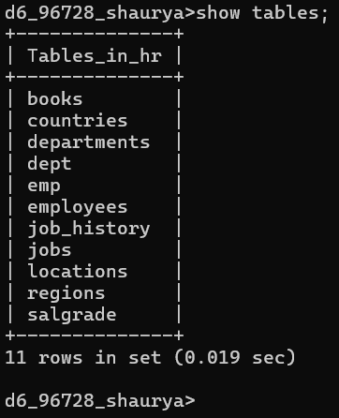

- Write a query to get unique department ID from employee table.
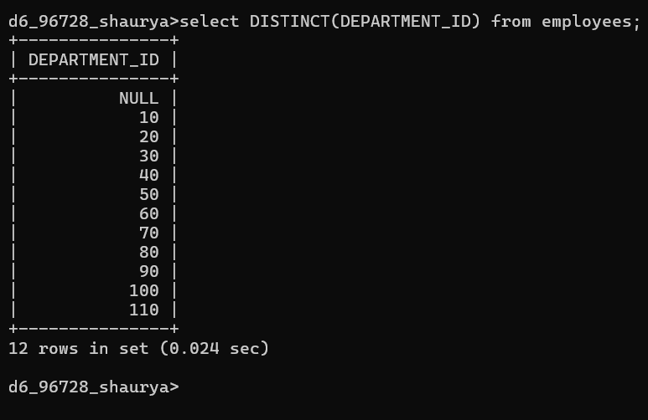

- Write a query to get all the employee’s details from the employees table displaying the first names in descending order.
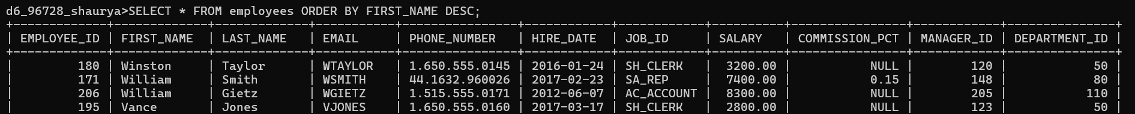

- Write a query to get the employee ID, names (first_name and last_name), salary in ascending order of salary.
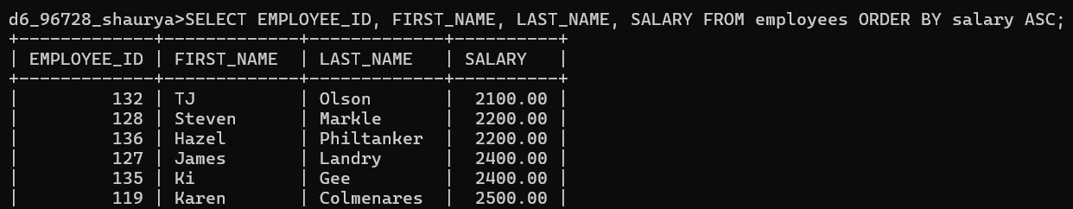

- Display first name and joining date of the employees who are either IT Programmer or Sales Man.

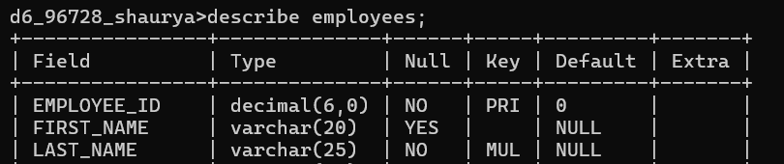

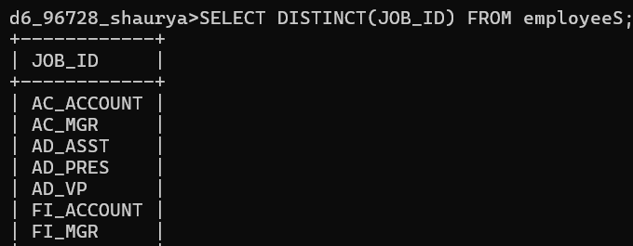

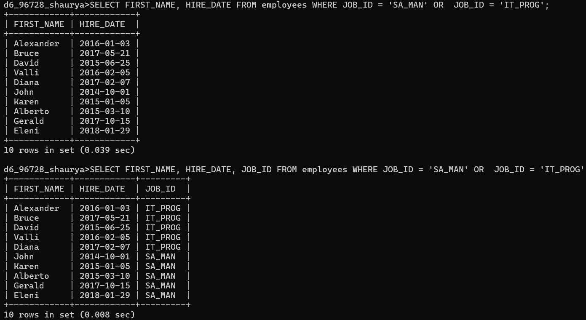

- Display details of employees with employee ID 150 or 160.
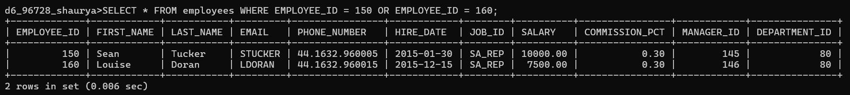

- Display first name, salary, commission pct, and hire date for employees with salary less than 10000.
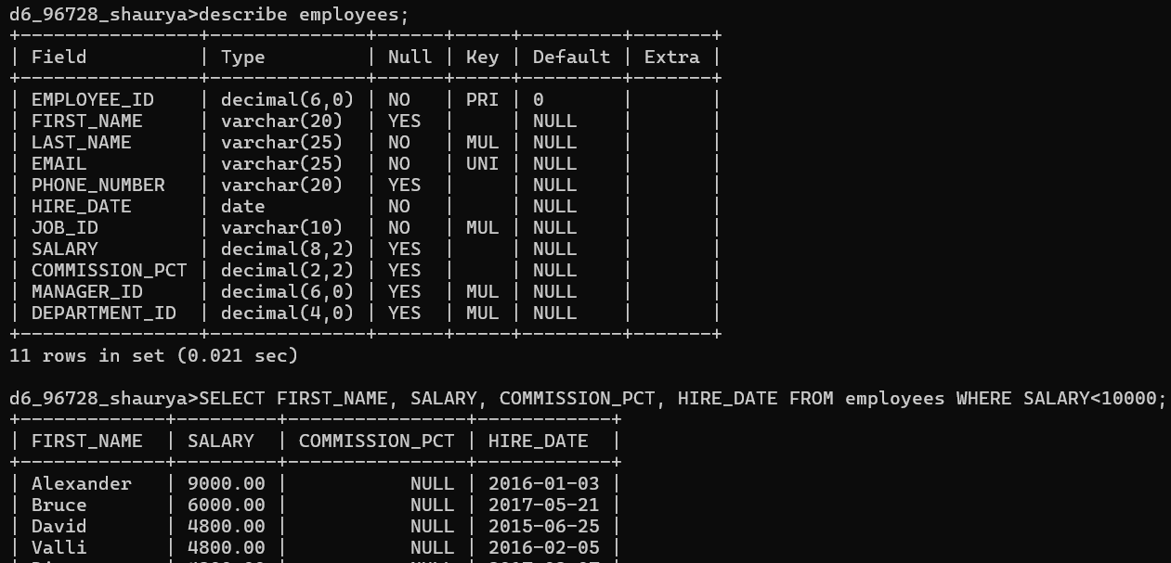

- Display employees where the first name or last name starts with S.
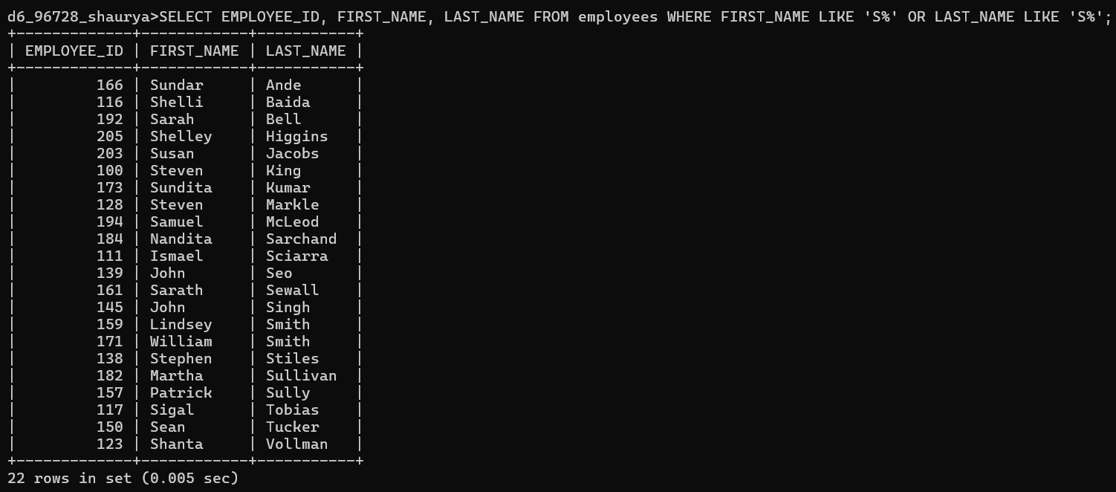
- Display details of jobs in the descending order of the title.
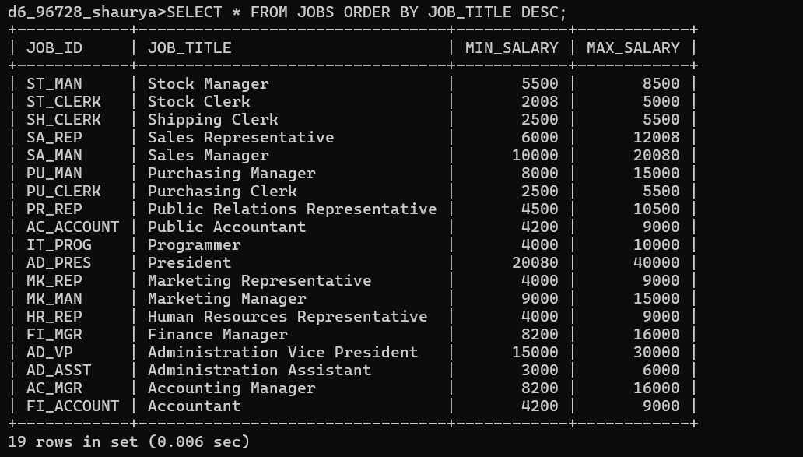

- Display the details of the employees from department 30, earning the salary greater 10000 but do not receive the commission.
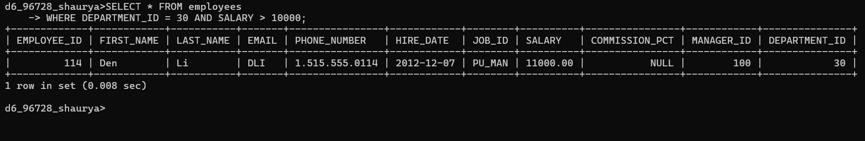
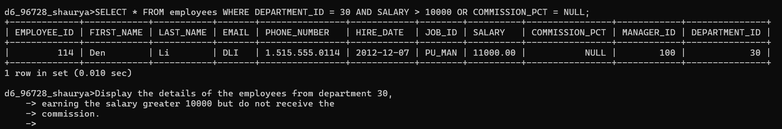
- Display the details of employees reporting to the managers with employee id 100 and 120.
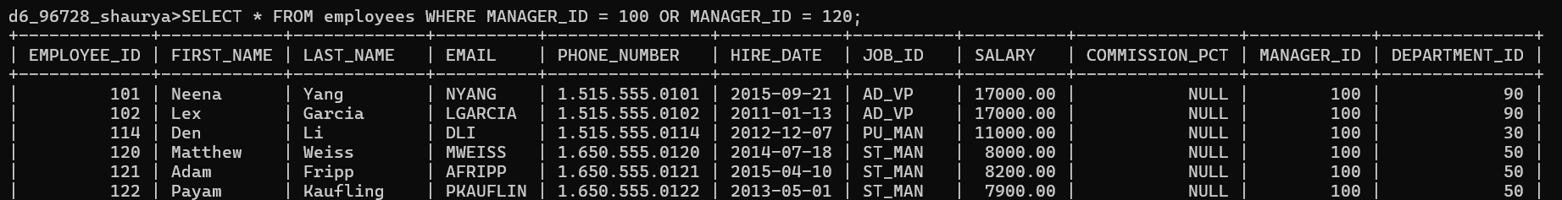

- Display the unique country_id from locations table.
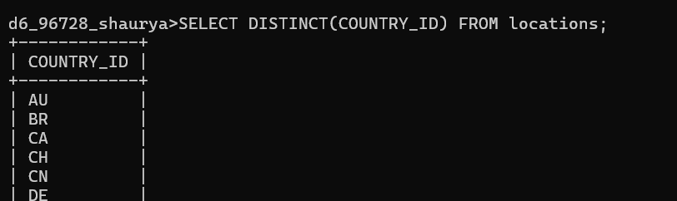

- Display all employees who have the job_id as IT_PROG and FI_ACCOUNT
